

**CERTIFIED ACCOUNTING TECHNICIAN**

**LEVEL 1 EXAMINATION**

**L1.4: BUSINESS MATHEMATICS**

**WEDNESDAY: 5 DECEMBER 2012**

**INSTRUCTIONS:**

1. **Time Allowed: 3 hours 15 minutes** (15 minutes reading and 3 hours writing).
2. This examination has **six** questions and only **five** questions are to be attempted.
3. Marks allocated to each question are shown at the end of the question.
4. Show all your workings, where applicable.

© iCPAR

***Attempt any five questions***

**QUESTION ONE**

1. Define the following terms as used in index numbers:

|  |  |  |
| --- | --- | --- |
|  | Base period. | **(2 marks)** |
|  | Chain index number. | **(2 marks)** |
|  | Quantity index. | **(2 marks)** |
|  | Retail price index. | **(2 marks)** |

1. The table below shows the quantities of **four** types of products consumed by a certain household in the years 2010 and 2011 and the unit price for each type of product.

|  |  |  |  |  |
| --- | --- | --- | --- | --- |
|  | **2010** | | **2011** | |
| **Types of products** | **Price per kg** | **Quantity** | **Price per kg** | **Quantity** |
|  | **Frw** | **kg** | **Frw** | **kg** |
| A | 500 | 100 | 800 | 120 |
| B | 800 | 140 | 1000 | 120 |
| C | 400 | 150 | 800 | 110 |
| D | 500 | 100 | 900 | 100 |

**Required:**

Using year 2010 as the base year, calculate:

|  |  |  |
| --- | --- | --- |
|  | Laspeyre’s price index. | **(4 marks)** |
|  | Paasche’s price index. | **(4 marks)** |
|  | Fisher’s ideal price index. | **(4 marks)** |

**(Total 20 marks)**

**QUESTION TWO**

1. Briefly explain:

|  |  |  |
| --- | --- | --- |
|  | Square matrix. | **(2 marks)** |
|  | Null matrix. | **(2 marks)** |

1. A company deals in the distribution of three types of products namely A, B and C. The company recently conducted a market survey to determine the product preferences of 90 households in a certain town. The following results were obtained from the survey:

* 50 households used A.
* 42 households used C.
* 18 households used B.
* 26 households used the A and C.
* 8 households used the A and B.
* 4 households used the C and B.
* 4 households used all the three products.

**Required:**

|  |  |  |
| --- | --- | --- |
|  | Represent the above information using a venn diagram. | **(5 marks)** |
|  | The number of households that used A but did not use B | **(2 marks)** |
|  | The number of households that used none of the three products. | **(2 marks)** |
|  | Probability of using C only | **(3 marks)** |
|  | Probability of C and B | **(4 marks)** |

**(Total 20 marks)**

**QUESTION THREE**

1. Distinguish between the following terms:

|  |  |  |
| --- | --- | --- |
|  | Simple interest and compound interest. | **(2 marks)** |
|  | Future value and present value. | **(2 marks)** |

1. A investment scheme offers to double your money in 8 years. What compound rate of interest is the scheme offering per annum?

**(4 marks)**

1. An investor wishes to invest Frw 100,000 for a period of four years. Two investment plans are being considered.

PLAN A: This will offer to pay 12% interest per annum, with interest compounded annually.

PLAN B: This will offer to pay 11% interest per annum, but with interest compounded semi annually.

**Required:**

Advise the investor on the better investment option.

**(6 marks)**

1. An investor invests Rwandan francs 20,000 at the beginning of each year and withdraws Rwandan francs 1,500 at the end of each year.

**Required:**

How much money will have accumulated after 10 years if the money is invested at 5% per annum compound interest?

**(6 marks)**

**(Total 20 marks)**

**QUESTION FOUR**

Your company manufactures components for use in the production of motor vehicles. The number of components produced each day over a forty-day period is the tabulated below:

|  |  |  |  |  |
| --- | --- | --- | --- | --- |
| 553 | 526 | 521 | 528 | 538 |
| 523 | 538 | 546 | 524 | 544 |
| 532 | 554 | 517 | 549 | 512 |
| 528 | 523 | 510 | 555 | 545 |
| 524 | 512 | 525 | 543 | 532 |
| 533 | 519 | 521 | 536 | 534 |
| 541 | 535 | 531 | 551 | 535 |
| 519 | 530 | 549 | 518 | 531 |

**Required:**

1. Group the data in five classes.

**(7 marks)**

1. Draw the histogram of the frequency distribution that you have obtained in (a**)**

**(5 marks)**

1. Establish the value of the mode of frequency distribution from the histogram.

**(3 marks)**

1. List **five** advantages of presenting data using graphs and diagrams.

**(5 marks)**

**(Total 20 marks)**

**QUESTION FIVE**

1. Identify **four** areas in which the **“What if”** facility available in spreadsheet could be useful to an accountant.

**(4 marks)**

1. In relation to a spreadsheet explain the following terms:

|  |  |  |
| --- | --- | --- |
|  | Workbook | **(2marks)** |
|  | Worksheet | **(2 marks)** |
|  | Cell | **(2 marks)** |

1. 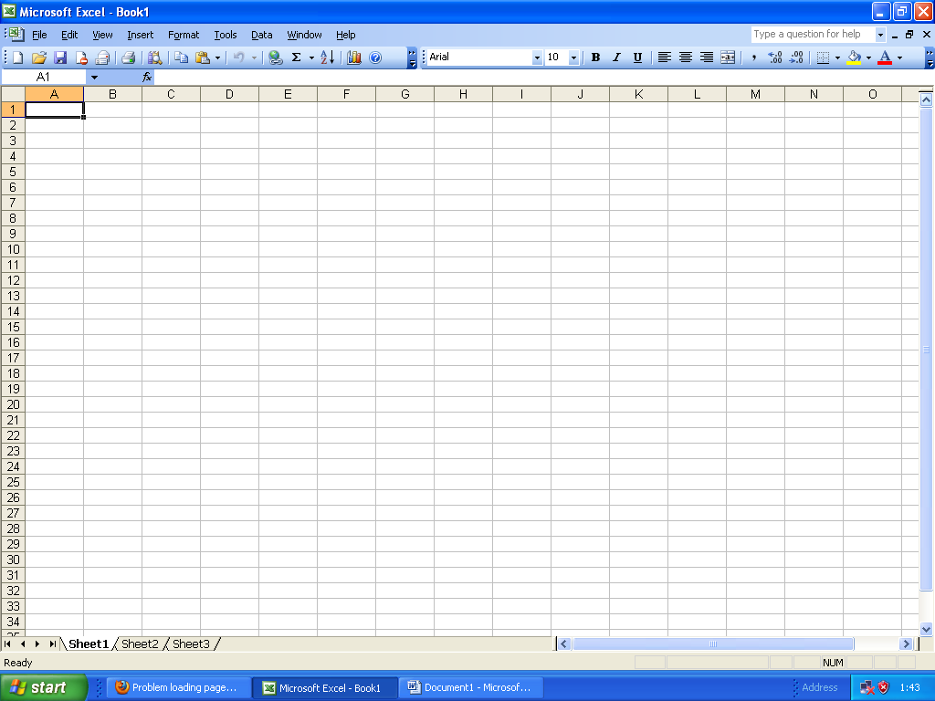 Give the steps you would take to display the worksheet shown below on your computer:

**(2 marks)**

1. In 2010, a factory had 4,000 workers, out of which 3,300 were members of a trade union. The total number of women workers was 500, out of which 400 did not belong to the trade union.

In 2011, the number of workers in the union was 3,450 of which 3,200 were men. The number of non-union workers was 760 of which 330 were women.

**Required:**

Present the information in the above scenario in a tabular form.

**(8 marks)**

**(Total 20 marks)**

**QUESTION SIX**

The following data was observed in 2011 in business survey from the sales of a set of products in Camellia restaurant

|  |  |  |  |  |  |  |  |  |  |  |
| --- | --- | --- | --- | --- | --- | --- | --- | --- | --- | --- |
| African Tea (X) | 15 | 24 | 25 | 30 | 35 | 40 | 45 | 65 | 70 | 75 |
| Passion juice (Y) | 60 | 45 | 50 | 35 | 42 | 46 | 28 | 20 | 22 | 15 |

1. Give an interpretation of your findings in (i) above **(2marks)**
2. Using the least square model derive the linear relationship by establishing the regression function **(8marks)**
3. Use the regression function in (ii) above to forecast the number passion juice to be sold if 10 cups of African Tea is the only order for the next day. **(2marks)**
4. Outline the commonly used measures of central tendencies  **(4marks)**
5. List and explain the advantages and disadvantages associated with Arithmetic mean as a measure of central tendencies. **(4marks)**

**(Total 20 marks)**

**End of question paper**